**Experiment No. 9**

**Aim:** Create a background application that will open activity on specific time.

**Program:**

* **Activity.xml :-**

*<?*xml version="1.0" encoding="utf-8"*?>*<RelativeLayout xmlns:android="http://schemas.android.com/apk/res/android"  
 xmlns:app="http://schemas.android.com/apk/res-auto"  
 xmlns:tools="http://schemas.android.com/tools"  
 android:layout_width="match_parent"  
 android:layout_height="match_parent"  
 android:background="@color/green"  
 tools:context=".MainActivity">  
  
 <ImageView  
 android:id="@+id/img"  
 android:layout_width="150dp"  
 android:layout_height="150dp"  
 android:layout_centerInParent="true"  
 android:layout_marginStart="25dp"  
 android:layout_marginTop="25dp"  
 android:layout_marginEnd="25dp"  
 android:layout_marginBottom="25dp"  
 android:src="@drawable/supra" />  
  
 <ProgressBar  
 android:id="@+id/pb"  
 android:layout_width="wrap_content"  
 android:layout_height="wrap_content"  
 android:layout_below="@+id/img"  
 android:layout_centerInParent="true"  
 android:layout_marginTop="25dp"  
 android:indeterminateTint="@color/white" />  
  
</RelativeLayout>

* **activity_main2.xml :-**

*<?*xml version="1.0" encoding="utf-8"*?>*<RelativeLayout xmlns:android="http://schemas.android.com/apk/res/android"  
 xmlns:app="http://schemas.android.com/apk/res-auto"  
 xmlns:tools="http://schemas.android.com/tools"  
 android:layout_width="match_parent"  
 android:layout_height="match_parent"  
 android:background="@color/green"  
 tools:context=".MainActivity2">  
  
 <TextView  
 android:id="@+id/tv"  
 android:layout_width="wrap_content"  
 android:layout_height="wrap_content"  
 android:layout_centerInParent="true"  
 android:layout_marginStart="20dp"  
 android:layout_marginTop="20dp"  
 android:layout_marginEnd="20dp"  
 android:layout_marginBottom="20dp"  
 android:gravity="center"  
 android:padding="10dp"  
 android:text="It's Supra.... Ratatatatata"  
 android:textAlignment="center"  
 android:textSize="48sp"  
 android:fontFamily="cursive"  
 android:textStyle="bold"  
 />  
  
</RelativeLayout>

* **MainActivity.java :-**

package com.example.flashscreen;  
  
import androidx.appcompat.app.AppCompatActivity;  
  
import android.content.Intent;  
import android.os.Bundle;  
import android.os.Handler;  
import android.widget.ImageView;  
import android.widget.ProgressBar;  
  
public class MainActivity extends AppCompatActivity {  
  
 @Override  
 protected void onCreate(Bundle savedInstanceState) {  
 super.onCreate(savedInstanceState);  
 setContentView(R.layout.*activity_main*);  
 new Handler().postDelayed(new Runnable() {  
 @Override  
 public void run() {  
 Intent i = new Intent(MainActivity.this, MainActivity2.class);  
 startActivity(i);  
 finish();  
 }  
 }, 2000);  
 }  
}

* **MainActivity2.java:-**

package com.example.flashscreen;  
  
import androidx.appcompat.app.AppCompatActivity;  
  
import android.os.Bundle;  
  
public class MainActivity2 extends AppCompatActivity {  
  
 @Override  
 protected void onCreate(Bundle savedInstanceState) {  
 super.onCreate(savedInstanceState);  
 setContentView(R.layout.*activity_main2*);  
 }  
}

**Output:**

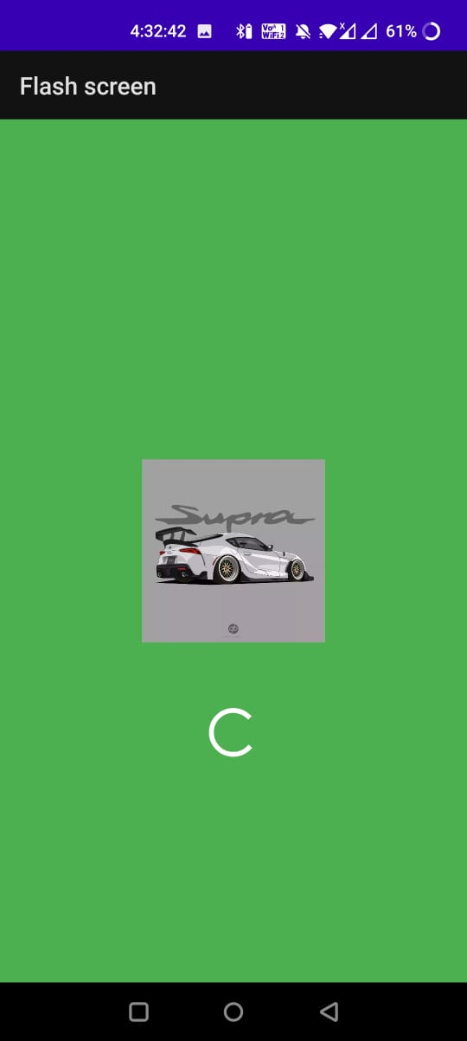 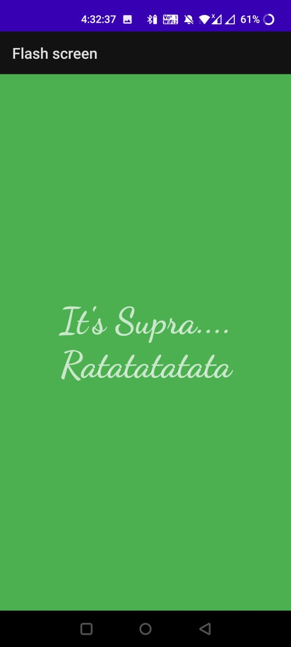



**Conclusion:**

Hence, by completing this experiment I came to know that how to Create a background application that will open activity on specific time.

|  |  |  |  |
| --- | --- | --- | --- |
| **Writeup & Oral**  **(4)** | **Practical Performance**  **(4)** | **Attendance**  **(2)** | **Total**  **(10)** |
|  |  |  |  |